

The Mayor’s Local Transport Plan for York and North Yorkshire

Case for Change

Consultation draft
August 2026
Large text version

York and North Yorkshire Combined Authority

Background and context

York and North Yorkshire Combined Authority
The York and North Yorkshire Combined Authority (YNYCA) was formally established on 1 February 2024, marking a significant shift in decision-making and funding powers from Westminster to the region. Led by the elected Mayor, David Skaith, the Combined Authority now has the responsibility of addressing local needs and aspirations more directly, with a Mayoral Investment Fund worth £540 million (£18 million per year for the next 30 years) secured through a devolution deal. This funding enables the Mayor to drive impactful projects across transport, housing, skills, and the transition to a low-carbon economy, benefiting communities throughout York and North Yorkshire.
The devolution order grants the Mayor powers in transport planning, including the production of a single local transport plan (LTP) for the area—previously the responsibility of City of York Council and North Yorkshire Council—and decision-making over a consolidated Mayoral Transport Fund, currently worth over £100 million per year.

Local transport plans
LTPs are statutory documents required under the Transport Act 2000 (as amended) and provide the strategic framework for planning, managing and investing in local transport systems. They set out a long-term vision for transport, supported by objectives, policies and delivery priorities, and play a central role in guiding decisions on infrastructure, services, maintenance and behaviour change. LTPs are also a key mechanism through which local transport authorities demonstrate how transport investment will support wider economic, social and environmental outcomes.
Historically, City of York Council and North Yorkshire Council have prepared and maintained their own LTPs, reflecting their distinct geographies and transport challenges. However, the establishment of YNYCA provides an opportunity to bring these approaches together into a single, coherent LTP covering the whole of York and North Yorkshire: the Mayor’s Local Transport Plan (MLTP). This joint plan will provide a consistent strategic direction for transport across urban, rural and coastal communities, while remaining sensitive to local context and need.

The Mayor’s Local Transport Plan for York and North Yorkshire
The Mayor’s Local Transport Plan for York and North Yorkshire will be formed of three main components:
- A long-term vision setting out what the MLTP is seeking to achieve in terms of economic, environmental and social outcomes
- A strategy setting out the actions that will be required to deliver the vision in terms of policies
- An implementation plan setting the detail on how the strategy will be delivered in the short-term.
This document sets out the strategic context in which the MLTP is being delivered, including the challenges and opportunities that the MLTP is seeking to address. This document also sets out a series of draft frameworks that the MLTP will be structured around, including a draft long-term vision and objectives for the MLTP.

Policy context
Transport policy plays a critical role in shaping economic development, social inclusion, environmental sustainability and public health outcomes. The MLTP will therefore need to reflect wider policy positions and strategies. The remainder of this chapter provides a review of relevant national, regional, and local strategies which will help ensure that decisions made in the MLTP are aligned to wider objectives.
Figure 1: Policy document hierarchy
National:
- Better Connected: A Strategy for Integrated Transport (2026)
- Local Transport Plan Guidance (2026)
- Quantified Carbon Reduction (2025)
Regional:
- The Mayor’s Vision (2024)
- York and North Yorkshire Strategic Transport Framework (2025)
- York and North Yorkshire Local Growth Plan (2025)
- York and North Yorkshire Economic Framework (2024)
- Spatial Development Strategy
- York and North Yorkshire Routemap to Carbon Negative (2025)
- York and North Yorkshire Skills Strategy (2024)
- Draft Strategy for a Sustainable Future (2026)
Local:
- York’s Local Transport Strategy (2024–2040)
- York Movement and Place Framework (2024)
- Local Plan for York (2017–2033)
- North Yorkshire Local Transport Plan 4 (2016–2045)
- City of York Council Plan (2023–2027)
- York Economic Strategy (2022)
- York Climate Change Strategy (2022)
- York Health and Wellbeing Strategy (2022)
- North Yorkshire Council Plan (2025–2029)

National context
The Department for Transport (DfT) has mandated that all local transport authorities (LTAs) are required to review and update their statutory LTPs to align with current national and local priorities, and to provide a more consistent basis for determining future investment priorities. New LTP guidance was released on 2 April 2026 explaining the relevant statutory duties and sets out the overall approach LTAs are expected to follow. The LTP guidance includes the following requirements:
- A vision-led or outcomes-focused approach which asks the following from the outset:
  - What outcomes do we want and need to achieve?
  - How will the scope of our transport evidence base and transport strategies combine to deliver them?
  - How are we prioritising and maximising sustainable transport options?
- Alignment between transport planning and other strategies produced by the LTA including:
  - the LTA’s local growth plan (LGP) or equivalent local economic strategy
  - the spatial development strategy (SDS)
  - local plans
- Provide the overarching transport strategy for their area and the strategic vision and context for other transport strategies, plans and schemes including Bus Service Improvement Plans and Local Cycling and Walking Infrastructure Plans
- A long-term view of transport needs for the area of at least 10 to 20 years.
- Support the government’s national priorities as well as the Department for Transport’s vision for domestic transport in England which is set out in ‘Better Connected: a strategy for integrated transport’.
- A quantified assessment of the carbon impacts of the LTP.

Better Connected: A Strategy for Integrated Transport (2026)
The new Integrated National Transport Strategy, published alongside the LTP guidance, sets out the UK government's long-term vision to create a safe, reliable, affordable, and accessible transport network in England. The strategy focuses on joining up different transport modes and empowering local leaders to reduce travel barriers and connect communities.
The strategy is driven by three core principles:
- People: Putting the passenger at the heart of the network by making services simple, dependable, and inclusive.
- Place: Ensuring transport networks help communities grow, thrive, and access essential services and jobs.
- Partnership: Working closely with local leaders and experts to tailor transport solutions to local needs.
The strategy is intended to support both national and local government by providing a clear national vision and set of priorities that should inform their choices. The document states that LTPs should be aligned with the vision and priorities set out in this strategy, ensuring local leaders are empowered to deliver locally integrated transport networks.

Quantified Carbon Reduction (2025)
In August 2025, the DfT published formal Quantifying Carbon Emissions for Local Transport Planning guidance to support LTP development. This guidance sets out practical methods for local authorities to integrate carbon analysis into transport planning and to quantify the carbon impacts of strategies, policies and specific interventions. It applies to both strategy development and subsequent scheme appraisal, providing methodological direction on how and when carbon analysis should be undertaken and what data and approaches can be used to support robust assessment.

Regional context

York and North Yorkshire Strategic Transport Framework (2025)
The York and North Yorkshire Strategic Transport Framework provides the overarching direction for transport policy and investment across the region. It sets out the strategic basis for the MLTP by defining the outcomes that the transport system must deliver to support thriving communities, a sustainable environment, and a resilient local economy.
At the centre of the Strategic Transport Framework are five transport objectives that guide future decision-making:
- Healthier travel: enabling more active and low-carbon travel choices to improve wellbeing and reduce transport-related emissions.
- Accessible for everyone: ensuring all residents, regardless of age, level of mobility, or location, can reach essential services and opportunities.
- Enhance safety: reducing risk across the transport network and creating safer conditions for all road and transport users.
- Protect our environment: supporting climate commitments, reducing environmental impacts, and contributing to nature recovery.
- Support economic growth: strengthening connectivity, improving network efficiency, and enabling productivity and investment.
Collectively, these objectives form a framework that shapes the priorities of the MLTP. They establish a shared ambition for a transport system that is inclusive, low-carbon, and economically enabling, providing long-term value for communities across York and North Yorkshire.
Regionally, the Strategic Transport Framework is informed by the Strategic Transport Plan developed by Transport for the North and aligns with transport strategies developed by City of York Council and North Yorkshire Council.

The Mayor’s Vision (2024)
The Mayor of York and North Yorkshire, David Skaith, was elected in May 2024 and has since confirmed his vision and priorities for the region.
The Mayor’s vision to make healthy and resilient communities, that are connected to opportunity, where people live in warm and affordable homes, where people are connected to the outdoors and where there are safe places for all.
The Mayor will use his devolved powers to:
- Create healthy and resilient communities – identifying gaps in provision and delivering a long-term plan for support services in the region
- Connect people to opportunity – creating an affordable, reliable, and sustainable transport system that puts passengers first and reduces dependency on the car
- Provide warm and affordable homes – delivering affordable and social housing, increasing innovation and support retrofitting to reduce energy costs
- Connect people to the outdoors – making outdoor spaces safe, accessible and affordable for everyone
- Ensure safe places for all – prioritising early intervention, tackling violence against women and girls, domestic abuse, anti-social behaviour and rural crime

York and North Yorkshire Local Growth Plan (2025)
The York and North Yorkshire Local Growth Plan provides a strategic foundation for delivering sustainable economic expansion across the region. It sets out how York and North Yorkshire will strengthen its business base, attract new investment, and build a resilient and competitive economy.
Vision for transformative growth: We will create the right conditions for growth, supporting our businesses and attracting greater investment.
To deliver this vision, the Local Growth Plan identifies a series of key outcomes that shape the region’s approach to economic development. These outcomes focus on strengthening economic performance, expanding opportunity, and embedding clean growth principles. Collectively, they aim to:
- Increase GVA and raise productivity across priority sectors.
- Generate higher-quality, secure employment that improves people’s long-term prospects.
- Broaden access to economic opportunities, ensuring benefits are shared across communities.
- Stimulate higher levels of public and private investment.
- Accelerate progress towards a carbon-negative economy by embedding low-carbon growth.
Looking further ahead, the Local Growth Plan emphasises a long-term impact of inclusive growth, ensuring that economic success is aligned with stronger communities and environmental stewardship. This future-facing ambition reinforces the importance of a transport system that can connect people to opportunity, enable business growth, and support a greener regional economy.

York and North Yorkshire Economic Framework (2024)
The York and North Yorkshire Economic Framework sets the strategic direction for long-term economic development across the region and provides essential context for transport planning. It outlines the economic conditions, priorities, and future aspirations that the MLTP must support to enable sustainable growth and improved quality of life. The Economic Framework positions the region to respond to global economic shifts while capitalising on its distinctive assets, workforce, and sectoral strengths.
The Economic Framework is built around three overarching ambitions:
- Transition to carbon negative: establishing a carbon-negative, circular, and more resilient economy that leads on clean growth and environmental innovation.
- Deliver inclusive economic growth: fostering a globally competitive, innovative, and productive economy with strong, thriving businesses across urban and rural areas.
- Increase opportunities for all: creating a more inclusive and thriving economy in which all communities benefit from improved skills, connectivity, and access to good employment.
These ambitions provide a strong strategic foundation for the MLTP, highlighting the importance of a transport system that supports clean growth, improves productivity, and connects people and businesses to new opportunities.

Other key documents
At the regional level, additional strategies provide important context for the MLTP by shaping the wider policy environment. The draft Strategy for a Sustainable Future (2026) sets out the region’s pathway to achieving its ambitious climate targets, outlining the actions and sectoral shifts required to reach carbon negative by 2040. It provides a clear mandate for accelerating decarbonisation across transport, energy and land use, reinforcing the need for cleaner mobility, modal shift and improved accessibility. It also broadens the focus beyond carbon reduction alone to embed decarbonisation within a wider framework of sustainable growth, resilience and environmental stewardship.
Complementing this, the York and North Yorkshire Skills Strategy (2024) focuses on strengthening the regional workforce to support future economic growth. It highlights current and emerging skills gaps, the importance of inclusive access to training, and the need to connect residents to high-quality employment opportunities. These priorities align closely with transport objectives related to connectivity, social mobility and strategic investment, underscoring the role of a well-functioning transport system in enabling people to access education, training and work.
YNYCA is preparing to develop a Spatial Development Strategy. This forthcoming strategy will provide a more integrated spatial framework to guide where growth should occur, how places should evolve, and how infrastructure, including transport, should be planned across York and North Yorkshire. It will help align economic, environmental and housing priorities at a sub-regional scale and support coordinated decision-making across administrative boundaries.

Local context

York’s Local Transport Strategy (2024–2040)
York’s Local Transport Strategy sets a long-term direction for how the city will develop a transport system that supports inclusive growth, environmental responsibility, and high quality of life. It provides an essential policy framework for shaping future investment and ensuring that transport contributes positively to York’s social, economic, and environmental ambitions.
The Strategy is anchored by a clear strategic vision:
In 2030 York residents will benefit from an accessible, affordable, sustainable and resilient transport network that continues to actively improve health and support a thriving economy for decades to come.
To deliver this vision, the Strategy identifies ten objectives that together define the attributes of a modern, people-focused transport system:
- support an inclusive, accessible, affordable city
- future-proof our city
- support delivery of the Climate Change Strategy
- improve the local environment by reducing air pollution and noise
- protect the city’s heritage and enhance public spaces
- improve health and wellbeing through healthy place shaping
- enhance safety and personal security
- support delivery of the Economic Development Strategy
- enhance the reliability of the transport system
- accommodate the envisaged growth of the city in the most sustainable way
The Strategy provides a strong contextual basis for the MLTP, ensuring alignment with York’s aspirations for a healthier, fairer, and more sustainable future.

North Yorkshire Local Transport Plan 4 (2016–2045)
The North Yorkshire LTP was adopted in 2016 and set out the long-term vision and objectives for transport across North Yorkshire, recognising the importance of linking communities, supporting economic growth, promoting safety, and addressing environmental impacts over the short, medium and long term. The Plan outlines strategic priorities and policies for managing transport services and infrastructure over a 30-year period, structured to allow thematic components to be updated as required.

York Movement and Place Framework (2024)
York's Movement and Place Framework (2024) is a strategic vision to rebalance how the city’s streets are used. It shifts transport planning away from car-dominated transport, focusing instead on creating safe, accessible and vibrant spaces that support the city's growth, climate goals and public health.
The framework is built upon six key pillars:
- Invest in the public realm: Transforming York’s streets from mere travel corridors into welcoming, safe, and family-friendly community spaces.
- Make connections: Creating highly connected, continuous networks for all forms of travel across the city, including its surrounding towns and villages.
- Determine the right traffic mix: Managing vehicle access in the city centre—such as balancing pedestrianization with access for deliveries, residents, and disabled badge holders.
- Enable active travel and public transport: Promoting walking, wheeling, and cycling as the obvious choices for everyday journeys, while supporting a major increase in local bus and train use.
- Define a multi-modal network: Establishing a clearly defined Key Route Network that accommodates a mix of transport modes—cars, freight, and public transport—while reducing overall city car dependency.
- Deliver projects on the ground: Translating these strategies into physical infrastructure, aligning with major regeneration schemes like York Central and the Local Plan.
City of York Council is in the process of developing a Movement and Plan which will establish a comprehensive city-wide approach to transforming transport infrastructure across all modes to help decision-makers adopt a ‘movement and place’ plan across York and surrounding settlements.

Local Plan for York (2017–2033)
The City of York Local Plan was formally adopted in February 2025 and covers the period from 2017 to 2033. It sets the statutory spatial planning framework for York, guiding land use, development and investment decisions through to 2033. The Plan establishes policies on housing, employment, infrastructure and environmental protection, including transport-related provisions that shape how future growth should be delivered in a sustainable and coordinated manner. It provides the basis for determining planning applications and integrating transport requirements with wider development priorities across the city.
While there is no equivalent Local Plan for North Yorkshire due to recent local government reform, the process development of a new Local Plan for North Yorkshire is underway.

Other key documents
At the local level, other documents help to shape the policy environment within which the MLTP will operate. The City of York Council Plan (2023–2027) sets out the Council’s priorities for building a fairer, greener and more resilient city. Its focus on community wellbeing, climate action, inclusive growth and improved public services provides a strong foundation for aligning transport interventions with broader place-based objectives. The Plan reinforces the importance of accessible neighbourhoods, sustainable travel choices and investment that supports long-term prosperity.
In York, a number of complementary long-term strategies also form part of the wider policy framework, including the Climate Change Strategy (2022), the Health and Wellbeing Strategy (2022) and the Economic Strategy (2022). These documents collectively support the integration of transport, climate, health and economic objectives within the MLTP.
The North Yorkshire Council Plan (2025-2029) sets the Council’s vision to ‘harness the power of North Yorkshire’s natural capital, unique communities and businesses, continuously improving our services to enable a good quality of life for all.’ The vision is supported by ambitions for thriving places and empowered communities, sustainable and connected places, safe, healthy and living well communities, and one council with strong local and customer led services.
In addition, a suite of modal plans and strategies covering areas such as cycling, walking, bus services, parking and freight provides detailed policy direction for specific elements of the transport system. These documents offer operational guidance and technical priorities that will inform the development of the MLTP, ensuring that the strategy is grounded in existing commitments while also identifying opportunities for integration, enhancement and innovation across the transport network.

Overview of York and North Yorkshire
York and North Yorkshire is a geographically diverse sub-region in the north of England, combining the historic city of York with the expansive rural county of North Yorkshire. The area spans urban centres, market towns, remote villages, coastal communities and national parks, leading to a distinctive mix of transport needs and opportunities.
The sub-region’s settlement pattern is highly varied: dense urban zones in York and places such as Harrogate and Scarborough contrast sharply with sparsely populated but nationally significant rural areas such as the Yorkshire Dales and the North York Moors (see Figure 2). North Yorkshire’s coastline also presents its own challenges with seasonal demand pressures on the transport network. This diversity shapes both the challenges faced by the local transport network and the opportunities available for a more sustainable future.
Figure 2: York and North Yorkshire overview
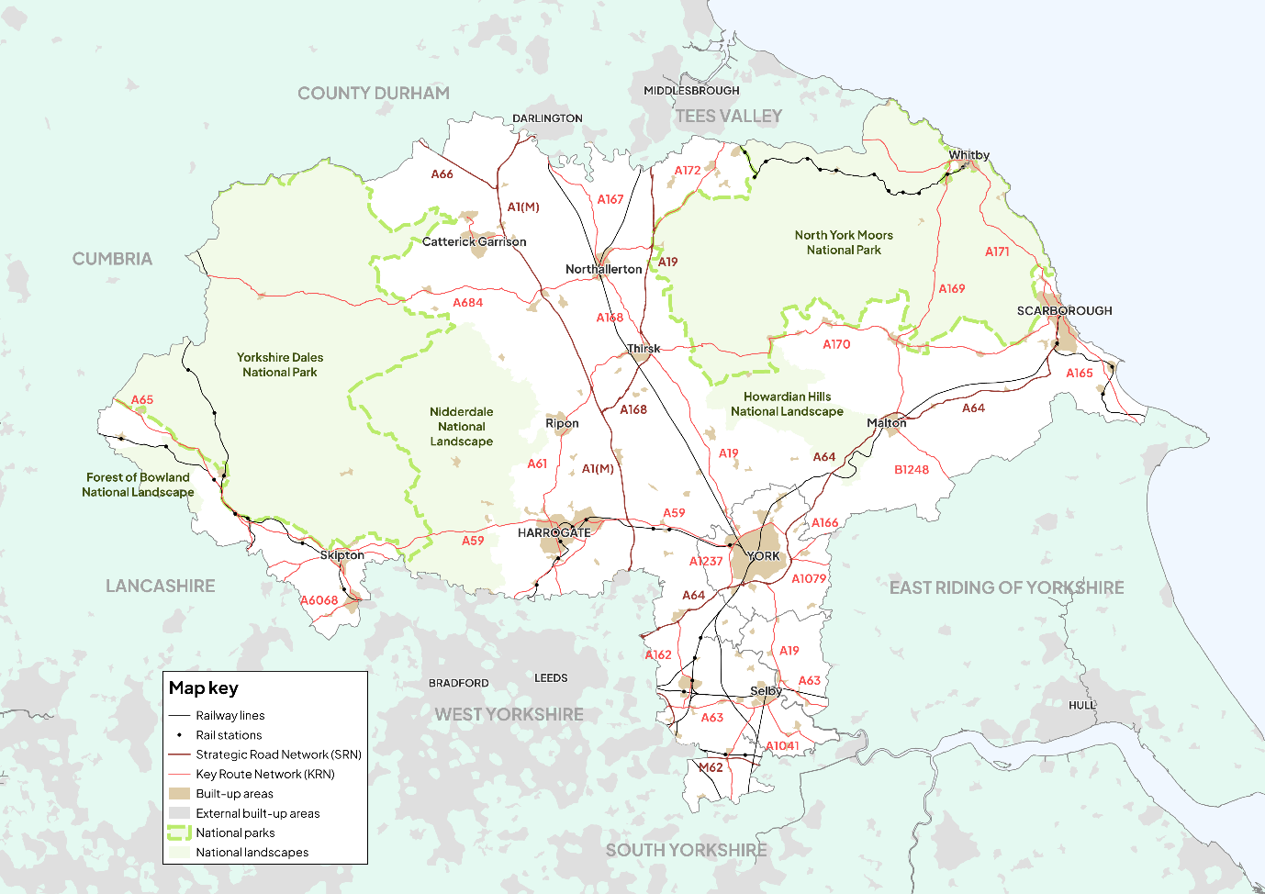

People
The population of the City of York is approximately 203,000 people, while the North Yorkshire council area is home to approximately 615,000 people. While the combined population of the area is therefore less than 1 million people, the total area is over 3,000 square miles in size. In comparison, the West Yorkshire Combined Authority area is home to 2.4 million people in an area just over 800 square miles, while the South Yorkshire Mayoral Combined Authority area is home to 1.4 million people in an area of just over 600 square miles. Compared to its neighbours, York and North Yorkshire therefore has a much smaller population spread across a much bigger geographical area.
Figure 3 shows population density across the region, illustrating the vast swathes of the area that are sparsely populated. In urban areas such as York, Harrogate, Selby, and Scarborough, population density reaches up to 5,000 people per square kilometre. In stark contrast, in more rural and some coastal areas, the population density is less than 500 people per square kilometre. In North Yorkshire as a whole, over 35% of people live in rural areas, while the remaining 65% live in urban areas that cover just 2% of localities.
Figure 3: Population density in York and North Yorkshire (2021)
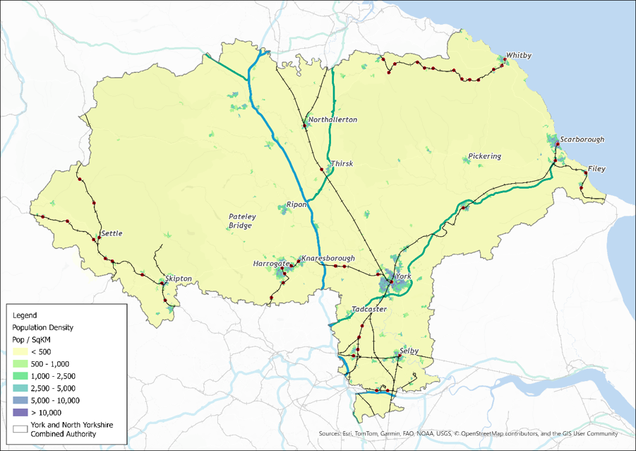
In terms of population structure, there are similarly huge variations across the geography as illustrated in Figure 4. While the City of York has a significant student and young adult population (approximately one-third of the population is under the age of 24 and there are almost 50,000 students in the city), this age group only represents a quarter of residents in North Yorkshire. In contrast, fewer than 20% of York’s residents are over the age of 65, while this group represents 25% of residents in North Yorkshire. In coastal areas, older age groups are even more prevalent, with almost 28% of residents in Scarborough aged over 65, according to the 2021 census.
Figure 4: Population structure in York and North Yorkshire (2021)
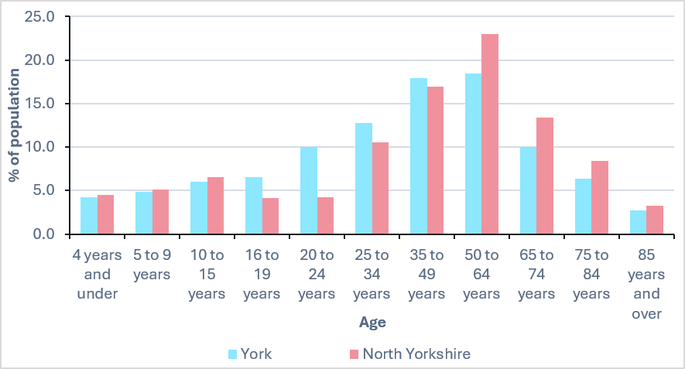
Source: Census 2021
These disparities continue when we consider forecast population growth. While the City of York’s population is expected to grow by around 6% between 2023 and 2032 (in line with national growth), the population of North Yorkshire is expected to grow by less than 4% during the same period.
Creating healthy and resilient communities is a key part of the Mayor’s vision for York and North Yorkshire. In the 2021 census, 82% of residents in York and North Yorkshire stated that their general health was either ‘very good' or 'good’ which was in line with the national average. However, health outcomes vary across the region with ‘very good' or 'good’ general health as high as 86% in Harrogate and as low as 80% in Scarborough. To address these variations, the Combined Authority has agreed to two programmes worth over £3 million to support healthy and thriving communities.
The safety of our roads and streets is a barrier to creating healthier communities. 60% of respondents in North Yorkshire’s Let’s Talk Transport consultation identified road safety as a key issue, while many said they do not feel safe walking or cycling. In York’s Big Transport Conversation, 61% of respondents said they do not walk, wheel or cycle as much as they would like, with safety concerns cited as a leading reason. The York and North Yorkshire Road Safety Partnership is also delivering targeted safety improvements to reach its vision to eliminate deaths and serious injuries on the region’s roads.

Economy
There is no doubt that York and North Yorkshire has a high-performing economy. It is home to 40,000 businesses, including major national and global institutions, such as Aviva, Nestlé, Siemens and McCains, but also has huge strength in its smaller sized businesses. The region has particular strengths in agri-business and food production, rail innovation, low-carbon technologies, and advanced manufacturing, including bus manufacturing (identified as priority growth sectors within the Combined Authority’s Growth Plan), alongside well-established heritage brands such as Taylors of Harrogate and Bettys. The outputs from some of its businesses are exported to 62 countries around the world demonstrating presence on the international stage.
Tourism also plays a critical role in the regional economy, with York, the Yorkshire coast and the two national parks attracting significant visitor numbers each year, supporting employment across hospitality, retail, culture and transport. While the region’s economy often outperforms other northern counterparts, there is still more to be done to compete with southern counterparts and ensure that the economy is thriving.
York and North Yorkshire has a highly productive economy with an average GVA per hour of £38.20 in 2023, making it one of the most productive areas in the North. However, productivity lags behind areas in the South such as Cambridgeshire and Peterborough where average GVA per hour was £40.30 per hour in the same period. Furthermore, average GVA per hour is only 90% of the England average. Despite being the fifth highest performing combined authority area, York and North Yorkshire has strong disparities across the region. The city of York itself performs very strongly with productivity rates surpassing the England average in 2023 (£43.50 per hour GVA). This makes it one of the most productive cities in Yorkshire and the Humber, ahead of Leeds (£41.50) and Sheffield (£36.10). In contrast, productivity in North Yorkshire has consistently fallen behind the national average. In 2023, GVA was £36.40 (20% below the York average), while average performance between 2013 and 2023 was just £30.60.
The Combined Authority’s Growth Plan is seeking to address the urban–rural divide in York and North Yorkshire by building on the strengths of urban centres while also enhancing the economic potential of rural areas. This will help to position the region as a major contributor to the UK’s journey achieving transformative growth. The Growth Plan identifies transport as a priority driver for growth to ensure that businesses have access to a diverse labour market. The Plan also notes that growth will put a strain on infrastructure (such as transport) which, without major investment; will become a constraint for growth. This aligns with the Rural Growth Trailblazer ambition to unlock rural productivity and remove structural barriers, including connectivity constraints, that limit labour market participation and business growth across York and North Yorkshire’s rural and coastal communities.

Environment
The region of York and North Yorkshire is one of the largest geographical areas in England, covering over 3,000 square miles of predominantly rural terrain. With two national parks, three national landscapes, and over 70% of land being used for agriculture, protecting the natural environment is a top priority for the Combined Authority.
As storms, floods and wildfires intensify across the world, there is growing urgency for collective action to tackle climate change. The Combined Authority therefore has an ambitious plan for York and North Yorkshire to become carbon negative as a region by 2040. This will require strong strategic direction and coordinated effort across all sectors to achieve.
Transport is the largest contributor to carbon emissions in York and North Yorkshire, making a larger contribution to emissions in York and North Yorkshire compared to the national average, and therefore has a key role to play in the decarbonisation of the region. Figure 5 shows average emissions from cars across the region, illustrating stark differences across the area. While no areas in the region fall into the lowest category of emissions, more urban areas such as York, Harrogate, Selby and Scarborough fall into the second-lowest category. In contrast, large swathes of the rural areas in the region fall into the highest category due to high levels of car usage. While this is not surprising given the limited alternative transport options in rural areas, reducing transport emissions in rural areas will be essential to the region achieving its carbon reduction goals.
Figure 5: Average carbon dioxide emissions from cars (2018)
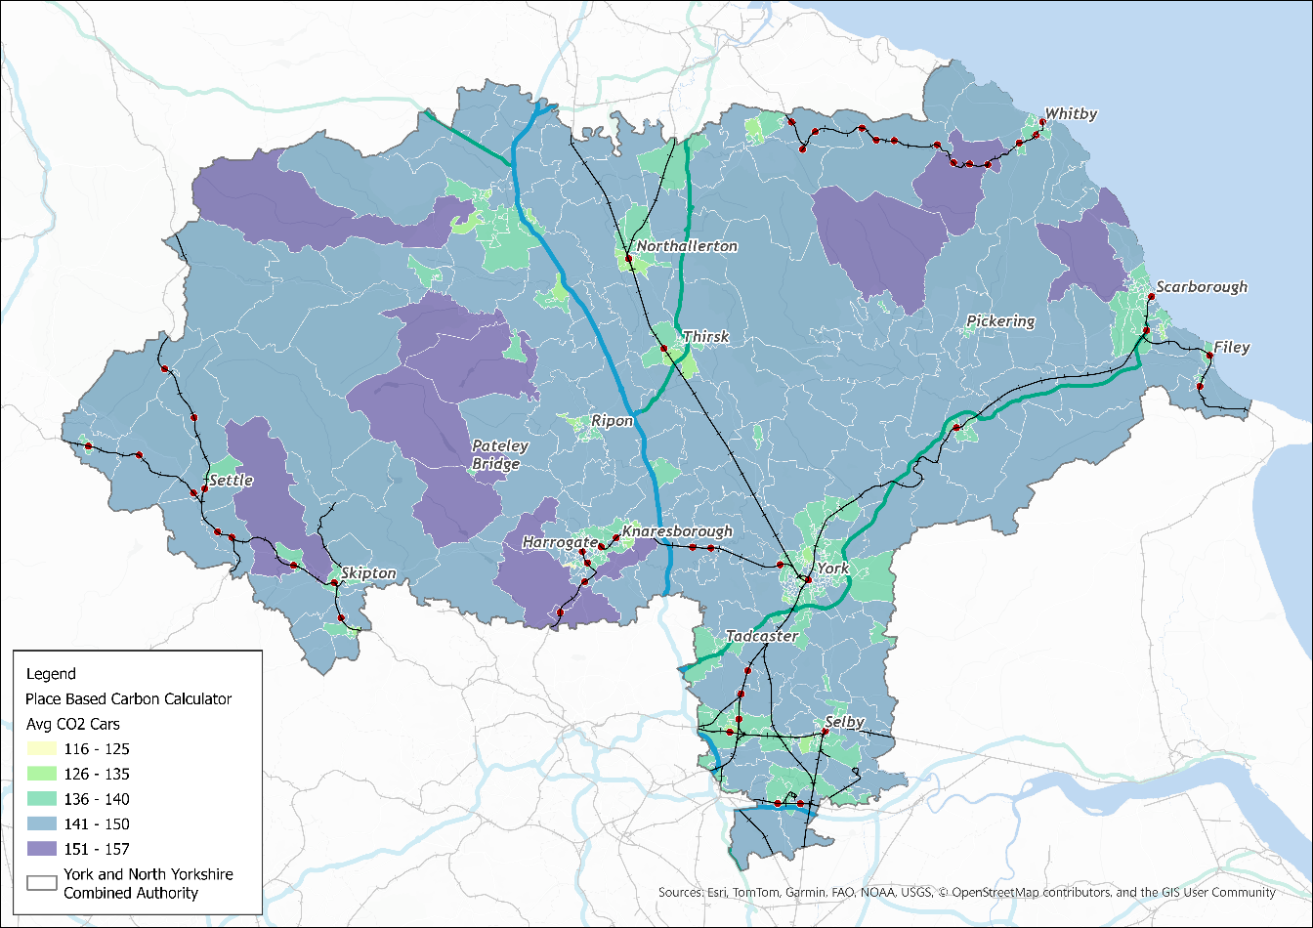
High levels of car usage can have a negative impact on air quality. Air Quality Management Areas (AQMAs) have been designated in both York and North Yorkshire because of national targets for pollutants not being met. Transport is a key contributor to air quality pollutants such as nitrogen oxide, as well as other impacts such as noise, which can have negative impacts on health.
The Combined Authority’s draft Strategy for a Sustainable Future sets out a vision for a ‘clean, integrated, accessible and affordable transport system’ with a strategic priority to make it easier for people to walk, wheel, cycle and use public transport. For this vision to be achieved however, investment in transport infrastructure is required to allow more people to use lower-carbon transport options. Evidence from the York and North Yorkshire carbon abatement pathways work, which underpins the Strategy, shows that transport emissions reductions rely on both technological change and substantial behavioural and modal shift, including reductions in private car travel and increased use of walking, wheeling, cycling and public transport, if the region is to meet its ambitious targets. Technological changes such as electrification on their own are unlikely to deliver the scale of decarbonisation required without these behavioural and systemic shifts.

Transport
York and North Yorkshire has several strategic transport assets. By rail, the East Coast Main Line provides north–south connections to London, Peterborough, Doncaster, Teesside, Newcastle and Edinburgh while the Transpennine route provides east–west connections to Hull, Scarborough, Leeds, Manchester and Liverpool. By road, the A1, M1 and M62 connect the region to key destinations such as Leeds, Sheffield and Hull, keeping people and businesses connected to the UK’s main road network. However, while road and rail connections to destinations outside the region are strong, the transport network within the region is limited, particularly outside of urban areas.
Buses are the backbone of the public transport network within York and North Yorkshire and provide a vital service for residents who do not have access to a car. Within York, where the proportion of non-car owning households is as high as 60% in some areas, the bus network is comprehensive, with the main operator First Bus providing regular services across the city, to nearby towns and villages, and to the six park and ride sites. Harrogate also benefits from a strong and well-used bus network, much of which is now operated by a predominantly electric vehicle fleet. However, in the rural parts of the region, bus service frequency is very low, with many areas having no service in the morning peak (see Figure 6). This results in high levels of car dependency, especially in rural areas. As part of the Combined Authority’s Bus Service Improvement Plan (BSIP), the Mayor is working with operators to grow the bus network across all parts of the region.
Figure 6: AM bus frequencies
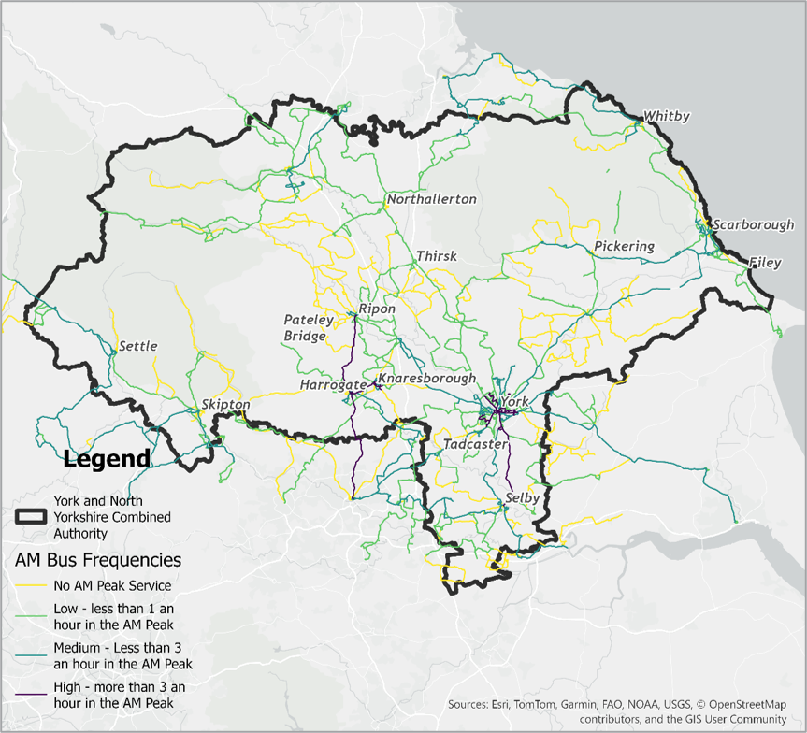
In a similar vein, the walking, wheeling and cycling network in York and North Yorkshire does not provide consistent coverage (see Figure 7). Within York, pedestrians and cyclists are top of the city’s transport hierarchy, with continued investment in infrastructure to support their needs. As a result, approximately 30% of all trips in York are undertaken by active modes (10% bike, 20% walking). In other towns too, such as Harrogate, the number of active travel-focused projects has increased in recent years. However, in rural areas, where journey distances are long and not always easily walked or cycled, investment in walking, wheeling and cycling has understandably been limited.
Figure 7: Cycle networks
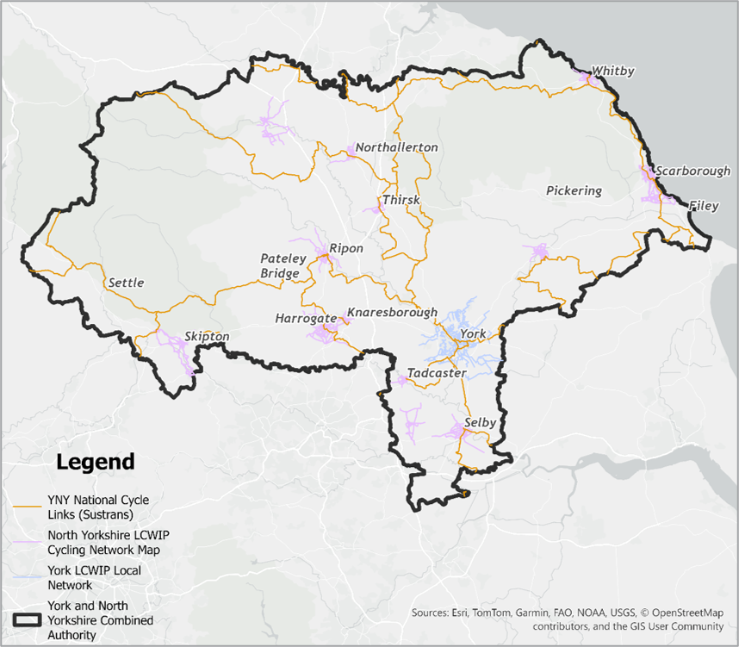
Table 1 shows that 24% of journeys in the CA area are under 1 mile in length, and encouragingly, 80% of these journeys are undertaken by active modes. However, as trip lengths increase, so does private vehicle mode share, with only 2% of trips between 5 and 10 miles undertaken by active modes. While the data is not split by place type (i.e., rural vs. urban), we expect longer trip distances to be more skewed towards rural locations.
Table 1: York and North Yorkshire mode share by distance band (nts-308_ca 2023 to 2024)
Distance band | Active transport | Private transport | % of all trip lengths
Under 1 mile | 80% | 19% | 24%
1 to under 2 miles | 43% | 54% | 19%
2 to under 5 miles | 12% | 84% | 25%
5 to under 10 miles | 2% | 94% | 14%
10 to under 25 miles | 2% | 90% | 12%
25 to under 50 miles | 0% | 90% | 4%
50 to under 100 miles | 0% | 85% | 1%
100 miles and over | 0% | 86% | 1%
Source: National Travel Survey
Note: The NTS data for public transport mode share is too small to be statistically relevant for all trip distances.
Residents who do not have access to a car or van, do not live in an area that is well served by public transport, and are not able to use active modes are at a much higher risk of experiencing transport-related social exclusion (TRSE). Figure 8 shows the risk of TRSE in York and North Yorkshire compared to the national level, using data from Transport for the North. The map shows that some areas of the region such as Selby, Filey and Scarborough fall into the highest risk category, meaning that they have very poor accessibility and very high vulnerability relative to other areas of England. TRSE is a lived experience for many residents in the region, reducing their ability to participate in society, access basic services or opportunities, or lead fulfilling and meaningful lives.
Figure 8: Transport-related social exclusion, national comparison (2021)
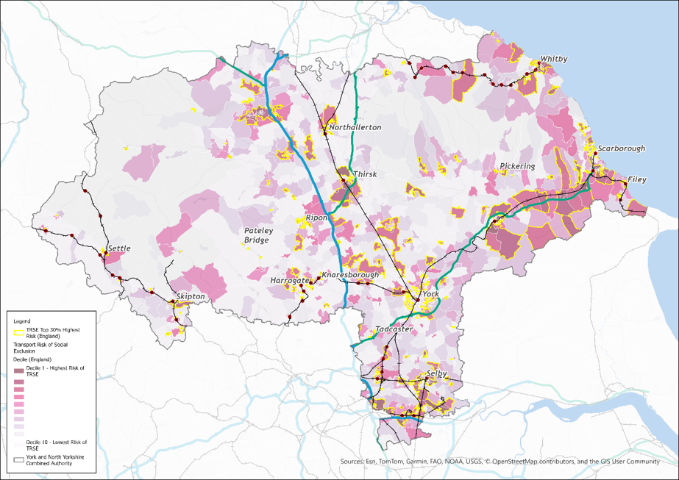

Connectivity
Lack of access to transport means that many people cannot access everyday services such as healthcare, education, employment and leisure. Recognising that this is an issue in York and North Yorkshire, we have undertaken some bespoke connectivity analysis for the region to understand how well people can access everyday services by different modes. We started by defining a series of spatial typologies as set out in Figure 9 and as follows:
- Urban: largest urban centres in the region, i.e., York, Harrogate and Scarborough
- Larger towns: larger settlements such as Whitby, Skipton, Northallerton, Ripon and Thirsk
- Smaller towns: smaller economic centres such as Pickering, Settle, and Helmsley
- Villages: smallest settlements such as Sherburn, High Bentham and Sheriff Hutton
- Rural: our most isolated rural settlements, including locations within the North York Moors and Yorkshire Dales national parks.
Figure 9: Spatial typology
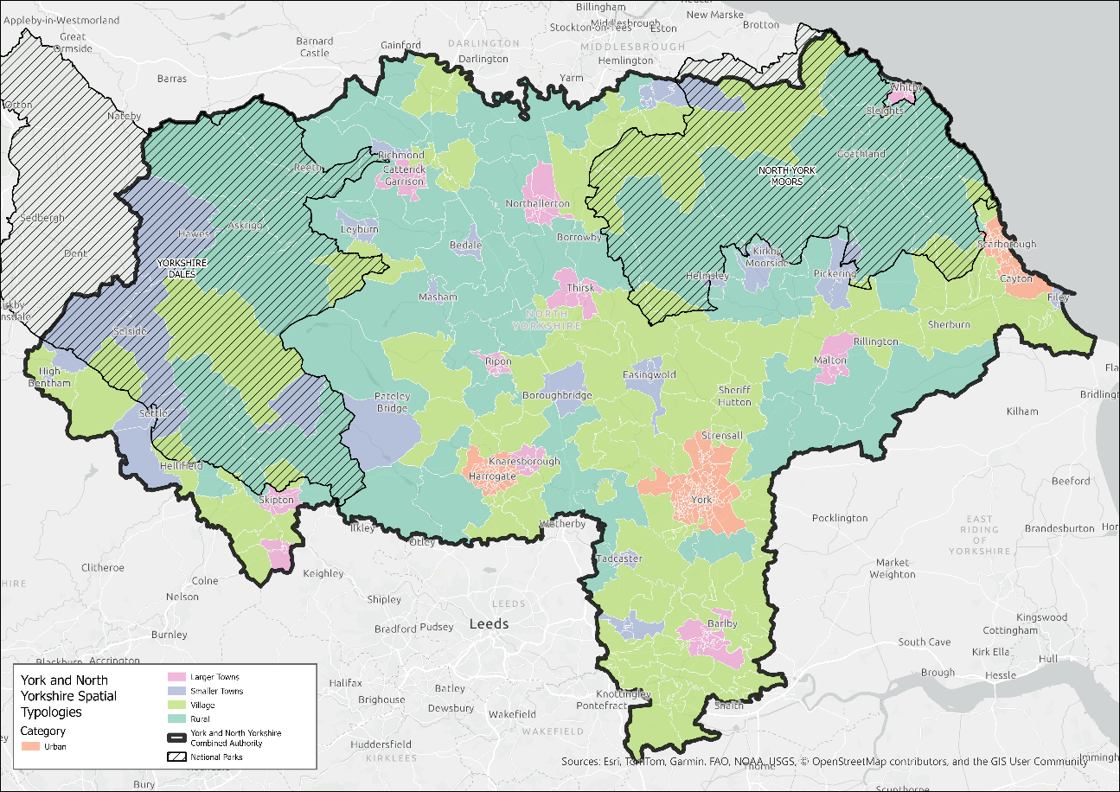
We then identified 14 key services which we wanted to understand connectivity to:
- primary school
- secondary school
- college
- GP surgery
- Hospital
- Pharmacy
- Dentist
- railway station
- bank
- post office
- supermarket
- green space (over 20 hectares)
- sports facilities
- leisure facilities
Our analysis works by identifying the travel time to each service by private vehicle, public transport, cycling and walking. This travel time is then compared to the average travel time of the spatial typologies each area is allocated to. This is important as it ensures that we are not comparing the connectivity of very dense and rural areas, but instead asking if the connectivity is good for a place of that type.
Figure 10 shows the overall connectivity of the region, combining all four transport modes analysed to produce an overall index of connectivity. The map indicates that levels of connectivity vary considerably and are strongly influenced by geography and the availability of public transport networks. Areas shown in dark blue generally experience better-than-average journey times to key services relative to their settlement type, while areas shown in dark red experience worse-than-average journey times. Several broad spatial patterns emerge from the analysis:
- Connectivity in urban areas is generally strongest within town and city centres, where both public transport provision and key services are concentrated. However, compared with other urban areas across York and North Yorkshire, parts of Scarborough have relatively lower levels of connectivity.
- Smaller towns and rural settlements located close to larger urban centres tend to have higher connectivity, reflecting their proximity to a wider range of services and more extensive transport networks.
- More isolated rural areas, particularly in the western parts of the region, experience the poorest levels of connectivity, with many locations having limited or no practical access to key services by public transport.
Figure 10: Overall connectivity
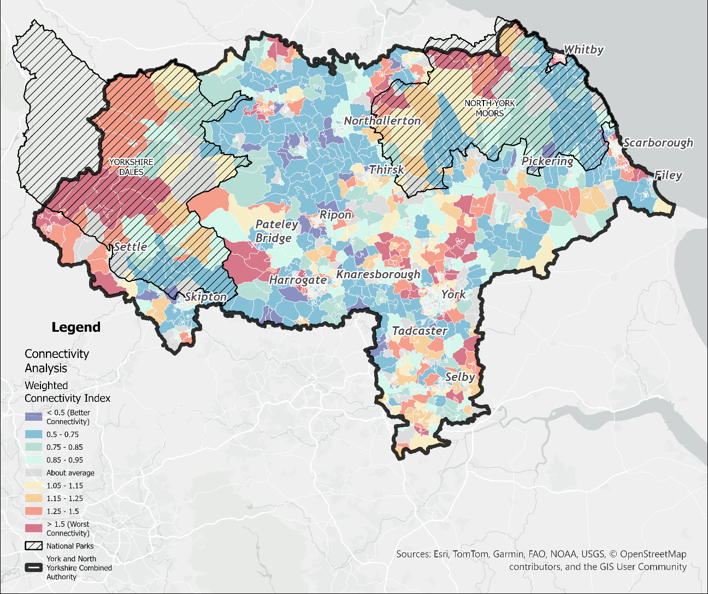
Figure 11 shows connectivity to key services by public transport only. The chart shows that 75% of residents can access all key services within a 45-minute public transport journey (with the exception of greenspaces which is 53%). Access by public transport is particularly strong for primary schools (94% of residents can access a primary school within a 15-minute public transport journey) and secondary schools (87% of residents can access a primary school within a 30-minute public transport journey). Access to GP surgeries, pharmacies, dentists, post offices, supermarkets and leisure facilities by public transport is also very strong.
However, some services have limited access by public transport for some residents, or in some cases are not accessible at all. Only 77% of residents can access a hospital within a 45-minute public transport journey, while 12% of residents cannot access a hospital at all by public transport. Limited access to healthcare facilities such as hospitals results in inequalities for those who don’t have access to a car and may cause delays seeking medical treatment.
Furthermore, only 53% of residents can access a greenspace (over 20 hectares) within a 45-minute public transport journey, while 27% of residents cannot access any by public transport. We know that having access to greenspaces is important for both physical and mental health and wellbeing and is a key element of the Mayor’s vision for healthy and thriving communities.
Figure 11: Connectivity by public transport
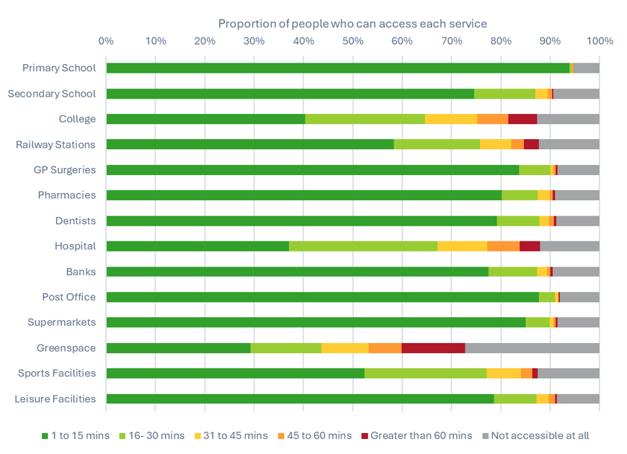

Challenges
While the region has many assets—a strong knowledge-driven economy, a thriving tourism sector, and excellent long-distance rail connectivity—it also experiences a series of challenges which hold it back from meeting its full potential. The Mayor of York and North Yorkshire is committed to championing the region and bringing a host of benefits to residents and businesses. This will start by addressing some of the key challenges summarised under the following sub-headings.

Geography
York and North Yorkshire’s geography shapes its distinctive travel needs and creates delivery challenges. The region’s sparse population makes it inherently difficult to provide public transport that suits the needs of most residents at an affordable level of subsidy, particularly in rural and remote communities. As a result, many residents have limited modal choice and must travel significant distances to access key services and employment. This often leaves the car as the only practical option and reinforces patterns of car dependency.
These poor levels of accessibility impact the lived experience of rural communities, many of which report isolation from key services and opportunities. The Devolution Deal for York and North Yorkshire referenced poor transport and digital connectivity in rural areas and deprivation in coastal areas, which puts York and North Yorkshire in the bottom 10% for social mobility nationally. Access to education, employment, healthcare and leisure can be significantly constrained, with transport availability, journey length and cost acting as barriers to participation and inclusion. As presented in the previous section, many coastal areas of York and North Yorkshire are at high risk of transport-related social exclusion.
At the same time, York faces very different but equally challenging spatial dynamics. The city is the hub of the region’s transport network (both road and public transport) which means it is also the focal point of many transport challenges. As a compact and historic city, its physical form limits the ability to expand transport capacity or introduce significant new infrastructure. This creates pressures on the existing network and highlights the need for innovative, space-efficient transport solutions.

Population
Demographic trends across York and North Yorkshire shape a series of complex transport challenges that influence service demand, accessibility, and long-term planning. Outside of York, the region has an ageing population, with the average age in North Yorkshire (48.7) notably higher than the national average (40.5). Rural and coastal areas have some of the highest concentrations of residents aged 65 and over (one third of the population in North Yorkshire), driving increased demand for health and social care services in locations where public transport options are often irregular or unavailable. This creates a structural mismatch between need and provision, with reliable, accessible transport being critical to wellbeing and social inclusion. The North Yorkshire Rural Commission’s 2021 report, The Way Forward, also highlighted the presence of a ‘missing generation’, identifying around 45,000 fewer working-age residents in the county than would be expected compared to the national age profile. This imbalance further reinforces the long-term demographic pressures facing the area.
By contrast, parts of York have an average age of 39.3 and a student population just under 50,000. In several neighbourhoods, fewer than half of households have access to a private car, increasing reliance on public transport, walking, wheeling, cycling and shared mobility. Ensuring these communities can access employment, education, and essential services places heightened emphasis on providing affordable, dependable, and high-quality alternatives to car use.
Demographic change also intersects with the region’s economic profile. Limited availability of high-skilled or specialist job opportunities has contributed to the out-migration of graduates and young professionals: a persistent ‘brain drain’ weakens the local talent pipeline and affects regional productivity. This trend aligns with North Yorkshire’s slower population growth compared to the national average, reflecting both the ageing population and the loss of younger working-age cohorts. Transport has a role to play in addressing this structural challenge, both by improving connectivity to employment centres and by supporting the attractiveness of the region as a place to live, work and build a career.

Economic inequality
While York benefits from a strong knowledge-based economy and GVA above the national average, many rural and coastal communities face a very different reality. Some of these areas experience lower wages, a higher prevalence of seasonal work, and more limited educational and employment horizons. These factors are consistently reflected in productivity data and social mobility indices. The result is a spatially imbalanced economy where opportunities are not evenly distributed.
Productivity, a core driver of living standards and wellbeing, lags behind national averages in several parts of the region. This challenge is compounded by the interaction between economic conditions and transport provision. In many cases, public transport does not adequately connect people to the places where opportunities exist, due to a variety of issues including infrequent services, limited operating hours, and network design that does not reflect current labour markets. Poor connectivity also restricts access to higher-value employment, training and essential services, reinforcing existing inequalities.
Transport therefore plays a critical enabling role: without reliable, affordable links between communities and opportunity, efforts to reduce inequality and improve long-term prosperity are significantly constrained. Addressing these structural gaps is essential to creating a fairer, more productive region.

Environment
York and North Yorkshire’s environmental context presents significant challenges that affect its resilience and make it more vulnerable to climate-related risks. Increased flooding and accelerated coastal erosion pose ongoing threats to infrastructure, communities and local economies. In rural areas, extreme weather events can isolate villages and hamlets, cutting off access to essential services and highlighting the fragility of existing transport links.
At the same time, the region’s high levels of car dependency contribute substantially to carbon emissions, air quality and pollution issues. Meeting the region’s climate commitments and transition towards cleaner, more sustainable mobility will be challenging given the long distances many residents must travel and the limited availability of viable alternatives to private car use.
Transport constraints are further shaped by the presence of nationally protected landscapes, including extensive national parks and national landscapes. While these assets are central to the region’s identity and visitor economy and are a significant environmental asset, they place limits on where and how new transport infrastructure can be delivered. In addition, there are numerous conservation areas, listed buildings and other important heritage assets across both North Yorkshire and the City of York, which require a sensitive design approach. In the City of York, the presence of 35 conservation areas and several flood risk zones also constrain potential transport improvements. In particular, the historic Roman city walls form a defining feature of York’s urban fabric and represent a significant physical and heritage constraint.

Housing
Housing pressures across York and North Yorkshire are closely intertwined with transport, shaping both where people live and how they travel. York faces an acute housing affordability crisis, with average house prices reaching nearly 11 times the average salary making it the 15th least affordable city in the UK. Between 2021 and 2022, average rents also increased by 10%, driven in part by student demand and the expansion of short-term holiday lets. This has furthered constrained the choices available to residents, particularly younger people and lower-income households.
Affordability challenges extend well beyond York. Across North Yorkshire, housing can be both expensive and sometimes of lower quality, with the average house price being ten times the average salary and 27% of the stock being built before 1919. In many rural areas, the lack of diverse, affordable housing can compound demographic imbalances and limit the ability of communities to attract or retain younger residents. In response, North Yorkshire Council has introduced a council tax premium on second homes to help address these pressures and support the delivery of affordable housing for local residents.
A further challenge lies in the sustainable delivery of new housing. Both councils are working to meet substantial housing delivery requirements, with North Yorkshire expected to plan for over 4,000 new homes per year and York targeting around 1,250 homes per year under current planning methodologies. Many potential development sites are in locations with limited public transport coverage and few realistic alternatives to car travel. Expanding housing supply without exacerbating car dependency, congestion and emissions requires careful coordination between spatial planning and transport investment. Without such integration, new developments risk locking in unsustainable travel patterns.

Tourism
Tourism brings a valuable economic boost to many parts of York and North Yorkshire, but it also places distinct pressures on infrastructure and local communities. North Yorkshire is one of the most visited places in the UK, welcoming 32.2 million visitors in 2024, a 3.8% increase from the previous year. In North Yorkshire alone, tourism supports more than 38,000 full-time jobs, making it one of the area’s most important industries. However, tourism in North Yorkshire is very seasonal, with large visitor numbers during the summer months. This generates sharp spikes in travel demand that place a strain on roads, parking and public services.
Seasonal fluctuations can be difficult to manage, especially in communities with limited capacity or infrastructure. A key issue is that many of the region’s leisure and tourist destinations are not accessible via public transport, making visitors reliant on private vehicles. This reliance leads to increased traffic on narrow rural roads and within areas of environmental or heritage importance such as national parks. In particular, key highway links such as the A64 towards the coast have significantly more traffic in summer than the rest of the year. This leads to significant congestion and delays on the road network, impacting both recreational and business and service journeys. Congestion, safety risks, wear on historic roads and traffic impacts on environmentally sensitive areas are common consequences.
In contrast, York is a tourist hotspot all year round with approximately 9 million visitors per annum. While the visitor economy supports 17,000 jobs and contributes £1.7 billion to the city’s economy, they place significant demand on the city’s infrastructure. York’s Tourism Strategy is seeking to grow the visitor economy in the city, but in a regenerative and sustainable way that maximises tourism’s contribution to the economy, employment and quality of life in York and beyond. Alongside this, North Yorkshire has its own ten‑year Destination Management Plan, delivered through Visit North Yorkshire, which sets out a long‑term, sustainable vision for growing the county’s visitor economy across urban, rural and coastal areas.
The Mayor is also considering the implementation of a new overnight visitor levy, which would result in visitors who stay overnight in the region paying a fee. It is estimated that, if implemented, the tax could raise revenues of over £50 million per year. This revenue would be reinvested to, for example, upgrade infrastructure and transport, maintain tourist attractions and public areas, and manage overcrowding from tourism.

Opportunities
Despite the challenges faced by York and North Yorkshire, the region also has a series of opportunities which, if maximised, could deliver transformational change. The Mayor has already been delivering programmes related to housing and transport and has agreed a series of draft strategic growth priorities for the region to help ensure that opportunities benefit everyone at a local level. Under the following sub-headings, we summarise some of the key opportunities which the region should be seeking to take advantage of.

Local leadership
York and North Yorkshire benefits from strong and proactive local leadership that creates favourable conditions for transformative change. The region’s Mayor brings a clear, future-focused agenda centred on creating “healthy and thriving communities,” setting an ambitious direction for policy, investment, and collaboration across the Combined Authority. The Mayor has been open about his approach to embracing change, including the potential to introduce an overnight visitor levy to raise additional revenue and the consideration of bus franchising.
Devolution has further strengthened the region’s ability to act. The newly secured devolved powers include access to a £540 million investment fund over 30 years dedicated to transport, skills and housing. While significant additional funding will be required for the region to achieve its ambitions, this long-term, flexible funding source is a starting point enabling the region to meet social needs, accelerate critical infrastructure projects, and unlock innovation in mobility and placemaking.
Underpinning these efforts is the Strategic Transport Framework, which provides a coherent and well-developed foundation for the MLTP. It offers a clear set of objectives from which to design interventions that are aligned, deliverable and strategically integrated. Having been recently established, the Combined Authority is a relatively new organisation, which is an opportunity in itself. A suite of new strategies across a range of themes are being developed in alignment with each other, which will help to guide the Combined Authority as it grows.

Low carbon and green growth
York and North Yorkshire is uniquely positioned to lead the transition to a low-carbon economy, with some of the most ambitious climate targets in the country. The region has committed to achieving carbon-negative status by 2040, putting it on track to become England’s first carbon-negative region. This commitment not only sets a clear strategic direction but also creates a strong mandate for innovation across transport, energy and land use.
This ambition opens significant opportunities for economic growth. By positioning itself at the forefront of decarbonisation, the region can attract new businesses, stimulate investment in clean technologies and generate high-quality green jobs. York and North Yorkshire’s Local Growth Plan identifies clean energy as one of the region’s five competitive advantage sectors which will result in stimulation of the supply chain and job creation. The Geothermal Demonstrator in North Yorkshire is a good example of the region’s commitment to exploring clean energies and providing lessons learnt for other sites in the UK.
In terms of transport, the demand for greener, more sustainable transport choices is already increasing. According to the National Travel Survey, 35% of trips in York and North Yorkshire are undertaken by active modes. This is higher than Greater Manchester (30%), South Yorkshire (31%) and West Yorkshire (32%), demonstrating strong public appetite for low-carbon travel and providing a foundation upon which to expand walking, wheeling, cycling, public transport, and shared mobility. Both York and Harrogate also benefit from bus networks that are now almost entirely electric, supported in part by Zero Emission Bus Regional Areas (ZEBRA) funding. These trends reinforce the potential for the MLTP to accelerate the shift towards cleaner, healthier and more resilient travel across the region.

Digital connectivity
Enhanced digital connectivity presents an opportunity to reshape mobility, access and economic inclusion across York and North Yorkshire. Continued expansion of high-quality digital infrastructure can enable more residents to work remotely, reducing the need for long-distance commuting and easing pressure on the transport network. Strong digital access also broadens employment horizons by connecting people in rural and coastal areas to higher-paid jobs that are not tied to a physical location. Progress in this area has already been made with the establishment of NYnet, a North Yorkshire Council-owned company that provides businesses and communities with fast, reliable broadband and has rolled out improved broadband services across numerous communities over the past decade. Alongside this, York has UNESCO ‘City of Media Arts’ status and was the UK’s first Gigabit City.
Improved connectivity additionally unlocks new ways of delivering services and supporting accessibility. There is growing potential to deploy digitally enabled transport solutions such as demand-responsive transport (DRT), which can provide flexible, efficient mobility in places where traditional fixed-route public transport services are difficult to sustain. These innovations can play a pivotal role in meeting the needs of dispersed communities, improving access to education, employment, health care and social opportunities.

Regional economy
The region’s economic strengths create a strong platform for transport-led growth. York’s knowledge-driven economy, underpinned by world-class universities, research institutions and high-value sectors, provides a solid foundation for expanding high-quality employment opportunities beyond the city itself. With the right connectivity, surrounding towns and rural areas can benefit from increased access to skilled jobs, innovation networks and higher-productivity industries.
Smaller urban centres across North Yorkshire also have significant potential to support their own economic specialisms. Improved transport can help these towns attract investment, support local business growth and stimulate wider regeneration. Strengthening connections between York and its neighbouring centres can create a more balanced, polycentric regional economy, enabling more residents to access opportunity without relocating.
The CA’s growth plan identified areas where the region has a clear competitive advantage such as engineering biology and life sciences, rail innovation, clean energy, the creative industries and food and farming innovation. This provides a starting point for when transport investment can be targeted to support the regional economy.

Place-based regeneration and sustainable development
There is potential across York and North Yorkshire to shape growth in ways that strengthen communities, enhance resilience, and reduce dependence on car travel. Regeneration initiatives across towns, rural villages and coastal communities provide an opportunity to prioritise sustainable transport, redesign streets and public spaces, and create environments that are safer, healthier and more people focused. By embedding sustainable mobility into regeneration strategies, places can become more attractive, vibrant and economically resilient.
York and other urban areas such as its market towns and larger villages are particularly well-suited to embracing the principles of sustainable neighbourhoods, particularly for first mile and last mile journeys. Their compact urban footprints offer a strong foundation for ensuring that residents can access most daily needs within a short walk, wheel or cycle. Delivering this model can reduce transport demand, support healthier lifestyles, stimulate local economies and strengthen community cohesion. City of York Council is in the process of developing a Movement and Place Plan which will influence how people move around the city in the future, focusing on placemaking rather than prioritising vehicle movements.

Our vision and frameworks

Our vision
York and North Yorkshire might be facing a series of challenges as presented in previous sections, but it also has huge opportunities to create a transport network that supports the needs of its people, economy and environment.
The Mayor of York and North Yorkshire, David Skaith, has a vision to enable healthy and thriving communities:
“I want to develop healthy and resilient communities, that are connected to opportunity, where people live in warm and affordable homes, where people are connected to the outdoors and where there are safe places for all.”
Transport is at the heart of the Mayor’s vision: connecting people to opportunities, creating healthy and resilient communities, connecting people to the outdoors, and ensuring safe places for all.
Taking the Mayor’s ambitions on board, we have developed an ambitious yet achievable vision for the MLTP to guide the transformation of our transport network. Our proposed overarching vision for the MLTP is built around four themes as set out in Figure 12.
Figure 12: Mayor’s Local Transport Plan vision

High-quality and well-connected urban, rural and coastal places for people to live, work, visit and socialise

Healthier, safer and more active communities

A productive and growing economy including our sustainable tourism offer, access to labour markets and movement of goods and freight

Transition to a decarbonised transport system which protects and enhances our natural environment, and connects our people to the outdoors

Principles of our transport network
For us to meet our vision for transport, we need to guide how the network is planned, designed and operated so that it meets the needs of everyone who uses it. We have therefore developed a series of overarching ‘principles’ for our transport network as set out below.
Provides sustainable choices: A transport network that provides a range of travel options to the places people need or want to go, so that everyone can choose the mode that best suits their needs.
Fully integrated: A carefully planned and coordinated transport network which offers seamless door-to-door journeys for everyone.
Supports active and healthy lives: A transport network that supports wellbeing by enabling our people to be more physically active in their day-to-day lives and enjoy our exceptional natural environment.
Accessible, inclusive and safe for all: A transport network that everyone can afford to use, is accessible and comfortable, and is safe for everyone, no matter their age, gender, race, level of mobility or the time of day.
Reliable and resilient: A transport network that is well maintained, well equipped to handle unexpected disruption, keeps people informed and can be relied on all year round.
Clean and green: A low-emission transport network that supports our commitment to achieving carbon negative status by 2040 and promotes greater biodiversity where possible.

Our integrated modes
Our transport modes will be key in delivering both our vision and objectives for the LTP and achieving our network principles. As set out below, we have grouped our modes into five categories.
Walking, wheeling and cycling: Walking, wheeling (including wheelchairs and mobility scooters) and cycling (including pedal-powered and electrically assisted pedal cycles) are the cheapest and most reliable forms of transport, as well as being excellent for physical and mental health and the environment. We need to expand and better connect our walking, wheeling and cycling networks, ensuring that travelling actively is a realistic option for more people and more journey purposes. Our ambition is for walking, wheeling and cycling to be an easy, safe and attractive way for people to undertake everyday short journeys.
Integrated public transport: Rail and bus are at the heart of the public transport network in York and North Yorkshire, providing vital connectivity for many of our residents, especially those who do not have access to a private vehicle and are unable to use more active modes of transport. However, our public transport network often does not provide a coherent, joined-up offer that allows people to easily and affordably switch from one service or mode to another. We want to deliver a more joined-up and seamless transport network that has greater reach into our urban, rural and coastal areas. Our ambition is for a fully integrated public transport network that provides reliable, accessible and safe connections to the places people need to go to live good lives.
Shared mobility: Many people in the region lack access to cars or cycles, and convenient connections to bus or rail services are often unavailable for the first or last parts of their journeys. We aim to introduce or improve various shared transport services in both urban and rural areas, ensuring our communities are better served and journeys are more sustainable. Our ambition is to create a shared mobility network that provides a convenient, accessible and reliable form of transport for a range of journey types.
Freight and logistics: Everyday, our road and rail network is used to transport goods to, from, and within our region and these movements are expected to grow. We need to ensure that goods moving through our network are doing so in the most efficient and sustainable way, while minimising negative impacts on local communities. Our ambition is to enable the efficient and reliable movement of goods across our region, while minimising impacts on local communities and the environment.
Private vehicles: Private vehicles, including cars, vans, and motorcycles, are a fundamental part of our transport network. They are often the only option for our remote communities or disabled people to access everyday needs and services. However, private vehicles also have a wide range of negative impacts on our places. As the region grows, we need to ensure that population growth is not accompanied by significant traffic growth which will exacerbate the negative impacts of traffic on everyone’s lives. Our ambition is to ensure that journeys that need to be undertaken by private vehicle are as reliable as possible, while minimising negative impacts on our people and places.

Our connected places
Our region consists of a diverse range of places which have their own distinct travel characteristics and needs. York and North Yorkshire’s MLTP will therefore adopt a place-based approach to recognise each area’s unique requirements that need to be met. Further details on each of the five place types we have identified to categories the travel needs of different places within the MLTP are outlined below.
Liveable neighbourhoods: As somewhere that many of us spend much of our time, our local neighbourhoods are some of our most important places. They should provide our people with good local amenities, foster a sense of community and create a sense of place where people feel safe and able to live good lives. We want to create liveable and connected neighbourhoods where people can easily, safely and conveniently access everyday services, jobs, education and green spaces within their local area through high-quality walking, wheeling, cycling and public transport networks, reducing reliance on cars and strengthening community life.
Towns and cities: Our towns and cities are hubs of employment, leisure, tourism and education and each one has its own distinctive needs and strengths based on its size, economy and surrounding geography. We need to ensure that more of our residents can access the opportunities available in the most sustainable way. We want our towns and cities to be seen as some of the safest, cleanest, healthiest and most vibrant in Europe.
Rural areas: Our region’s rural areas are one of our biggest assets: from characterful villages to expansive moorland, our rural offering is what makes us special. We need to ensure that people in rural areas have access to jobs, education, services and leisure opportunities and that people have access to the outdoors, while also protecting our rural areas from the negative impacts of car-dominated travel. We want to provide a genuine choice for people living in rural areas so they can access the everyday destinations they want and need to by car or by sustainable transport, supporting rural communities and enhancing our tourist economy.
Coastal areas: Our region also has beautiful coastal areas from quaint fishing villages to picturesque seaside towns. Our coastline is a standout feature in our region that attracts locals and visitors alike. We want to ensure that our coastal areas are well served by public transport, walking, wheeling and cycling networks that support the needs of local communities and visitors. We want to support our coastal communities so that people have the same access to education, jobs and other opportunities as those living further inland, creating healthy and thriving places to live and work, and better enable them to maximise the benefits of the tourist economy while being resilient to the pressures of seasonal tourist demand.
Destinations outside of the region: Our region neighbours seven other combined authority areas which have key destinations that our people need to travel to for education, employment, leisure and health opportunities. It’s also crucial for our economy that goods can move efficiently in and out of the region. We want to enable seamless journeys across administrative boundaries to reflect the interconnected nature of our geography and travel habits, whether people are making everyday commute trips to or from our larger urban neighbours or travelling further afield.

References

All Local Transport Authorities (LTAs) are required to prepare a Local Transport Plan by the Transport Act 2000 (Transport Act 2000 (legislation.gov.uk) – and amended by the Transport Act 2008.
https://www.york.gov.uk/statistics-information/census/3
https://bothness.github.io/censusprofiles/E10000023/?year=2021
York and North Yorkshire Local Growth Plan (2025)
https://www.westyorks-ca.gov.uk/data/
https://www.britannica.com/place/West-Yorkshire
https://locate.southyorkshire-ca.gov.uk/community-profile.html?primaryColor=009CA6&secondaryColor=000000&country=3&icTool=community-profile
https://www.britannica.com/place/South-Yorkshire
https://edemocracy.northyorks.gov.uk/documents/s25208/Appendix%20A%20-%20Draft%20Housing%20Strategy%202024-29.pdf
https://www.york.gov.uk/downloads/file/10281/york-s-local-transport-strategy
https://edemocracy.northyorks.gov.uk/documents/s43024/Health%20in%20Coastal%20Communities%2020241129.pdf#:~:text=Scarborough%20and%20Whitby%20%E2%80%93%20Local%20Context%2048.6%25,older%20age%20profile%20than%20that%20of%20England.
https://www.york.gov.uk/downloads/file/9262/council-plan-2023-to-2027
https://www.varbes.com/population/north-yorkshire-population
https://yorknorthyorks-ca.gov.uk/3-million-to-help-keep-york-and-north-yorkshire-mentally-and-physically-well/
https://yorknorthyorks-ca.gov.uk/wp-content/uploads/2025/10/York-and-North-Yorkshire-Local-Growth-Plan.pdf#:~:text=Our%20region%20is%20home%20to%20nearly%20one,most%20productive%20combined%20authority%20in%20the%20North.
https://yorknorthyorks-ca.gov.uk/what-we-do/transport-york-north-yorkshire/#:~:text=Decarbonising%20Transport%20in%20York%20and%20North%20Yorkshire,options%20will%20help%20reduce%20the%20carbon%20footprint.
https://www.york.gov.uk/downloads/file/10281/york-s-local-transport-strategy
https://www.york.gov.uk/downloads/file/10281/york-s-local-transport-strategy
https://trse.transportforthenorth.com/
Natural England's Accessible Greenspace Standard dictates that all households should have access to an accessible green site of at least 20 hectares (ha) within 2 km of home, to promote well-being and outdoor recreation
https://www.gov.uk/government/publications/york-and-north-yorkshire-devolution-deal/york-and-north-yorkshire-devolution-deal
https://www.varbes.com/demographics/yorkshire-and-the-humber-demographics
https://www.varbes.com/demographics/north-yorkshire-demographics
https://www.yorkshiredales.org.uk/wp-content/uploads/sites/13/2025/07/Rural-North-Yorkshire-The-Way-Forward-Rural-Commission-July-2021.pdf?
https://www.varbes.com/demographics/york-demographics
https://www.york.gov.uk/downloads/file/10281/york-s-local-transport-strategy
https://www.yorkshiredales.org.uk/wp-content/uploads/sites/13/2025/07/Rural-North-Yorkshire-The-Way-Forward-Rural-Commission-July-2021.pdf?
https://www.york.gov.uk/council-plan-1/one-city-2023-2027/9
https://edemocracy.northyorks.gov.uk/documents/s25208/Appendix%20A%20-%20Draft%20Housing%20Strategy%202024-29.pdf
https://www.northyorks.gov.uk/council-tax/council-tax-second-homes?
https://www.northyorks.gov.uk/sites/default/files/2025-10/AMR%20for%20the%20North%20Yorkshire%20Local%20Plan%202024-2025.pdf?
https://www.yorkshire.com/news/north-yorkshire-tourism-new-advisory-groups-4bn-vision/
https://www.makeityork.com/visitor-economy/
https://democracy.york.gov.uk/documents/s171446/Appendix%20B%20-%20Tourism%20Strategy.pdf
https://www.northyorks.gov.uk/sites/default/files/2023-08/DMP%20North%20Yorkshire%20DRAFT%2014%20July%202023%20-%20accessible.pdf?
https://www.bbc.co.uk/news/articles/cgex57y0pgvo
https://yorknorthyorks-ca.gov.uk/rural-bus-franchising/
https://www.gov.uk/government/statistical-data-sets/nts03-modal-comparisons#trips-stages-distance-and-time-spent-travelling

